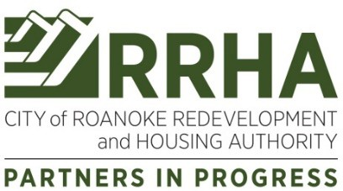

NOTICE OF PUBLIC HEARING

The City of Roanoke Redevelopment and Housing Authority (RRHA) will conduct a Public Hearing on the update to the 2025-2029 Agency Plan and the Capital Fund Program Five-Year Action Plan on May 18, 2026 at 3:00 p.m. at 2624 Salem Turnpike, NW, Roanoke, Virginia 24017.
The purpose of the hearing is: 1) to present the 2026 Annual Plan update to the 2025-2029 Agency Plan and receive public comments. The Annual Plan provides details about the agency’s policies, programs and services, residents’ concerns and needs, and plans for operations for the next five years; and 2) to present the Capital Fund Program Five-Year Action Plan and receive public comments. The Action Plan provides details about the agency’s plans for capital improvements in public housing for the next five years.

Draft copies of the 2026 Annual Plan update to the 2025-2029 Agency Plan and the 2026 Capital Fund Program Five-Year Action Plan will be available for review beginning April 1, 2026 on the RRHA website at www.rkehousing.org and at the following locations Monday through Friday from 8:30 a.m. to 5:00 p.m. In addition to the Public Hearing, comments can be directed to dbustamante@rkehousing.org.

RRHA Administrative Offices | Lansdowne Park | Morningside Manor
2624 Salem Turnpike, NW | 2624 Salem Turnpike, NW | 1020 13th Street, SE
Villages at Lincoln | Hunt Manor | Indian Rock Village
1801 Dunbar Street, NW | 802 Hunt Avenue, NW | 2034 Indian Village Lane, SE
Melrose Towers | Jamestown Place | Bluestone Park
3038 Melrose Avenue, NW | 1533 Pike Lane | 2617 Bluestone Avenue, NE

CITY OF ROANOKE REDEVELOPMENT AND HOUSING AUTHORITY
David Bustamante Executive Director EEO/AA
As set forth in the Americans with Disabilities Act (ADA) of 1990 and Section 504 of the Rehabilitation Act of 1973, RRHA does not discriminate on the basis of disability, and is willing to assist citizens with special needs. If you have a hearing or vision disability and wish to attend any RRHA public meeting, please contact us seven (7) days prior to meeting date at (540) 983-9286 or City of Roanoke Redevelopment and Housing Authority, 2624 Salem Turnpike, NW, Roanoke, VA 24017.

Date of Notice: March 29, 2026

