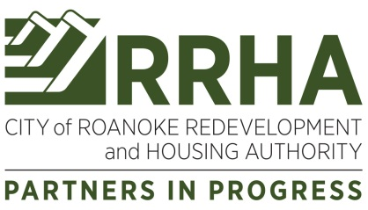

Public Notice of Meeting

The Regular Meeting of the

City of Roanoke Redevelopment and Housing Authority

Board of Commissioners

will be held on

Monday, July 25, 2022
at 3:00 p.m.

As set forth in the Americans with Disabilities Act (ADA) of 1990 and Section 504 of the Rehabilitation Act of 1973, RRHA does not discriminate on the basis of disability, and is willing to assist citizens with special needs. If you have a hearing or vision disability and wish to attend any RRHA public meeting, please contact us seven (7) days prior to meeting date at (540) 983-9286 or Roanoke Redevelopment and Housing Authority, 2624 Salem Turnpike, NW, Roanoke, VA 24017.

Date of Public Notice: July 18, 2022

